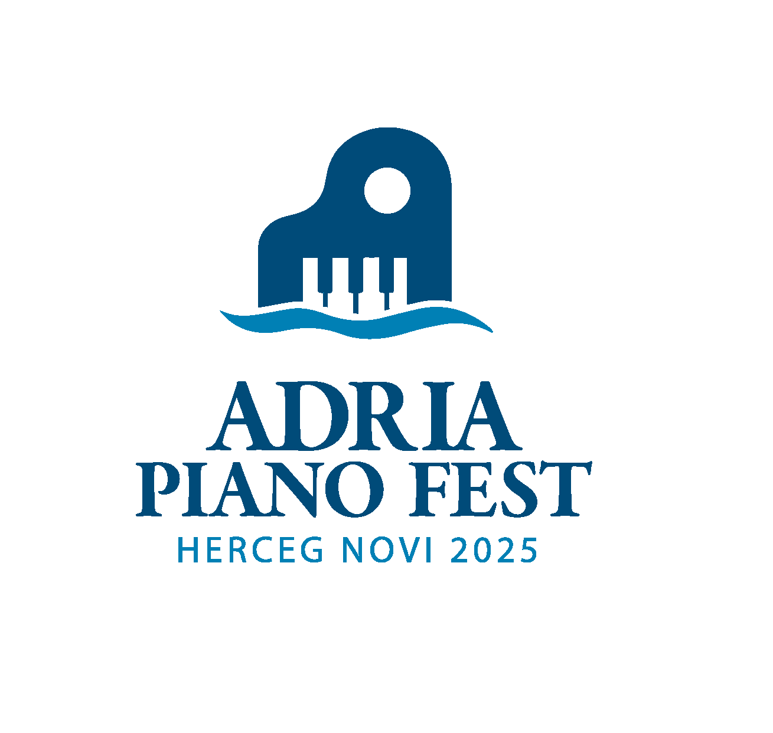Adria Piano Festival 16-18. jun 2025.

HERCEG NOVI

*- prijava / application form -*

e-mail:

Ime i prezime takmičara / Full Name of the participant:

Datum rođenja / Date of birth:

Muzička škola (akademija) / Music school (academy):

Grad i država / Country and city:

Ime i prezime profesora (mentora) / Full name of professor (mentor):

Kontakt telefon / Phone number:

Kategorija / Category:

Takmičarski program / Piano pieces for the competition:

Trajanje programa / Duration of the pieces: